**Full stack Assignment**

1. Basic HTML5 Structure

<html>

<head>

<title> My First HTML page </title>

</head>

<body>

<h1> Saniya Nishath</h1>

<p> I like to read novels , loves to hear music and songs , hiking in nature and exploring new technologies </p>

<hr>

<br>

</body>

</html>

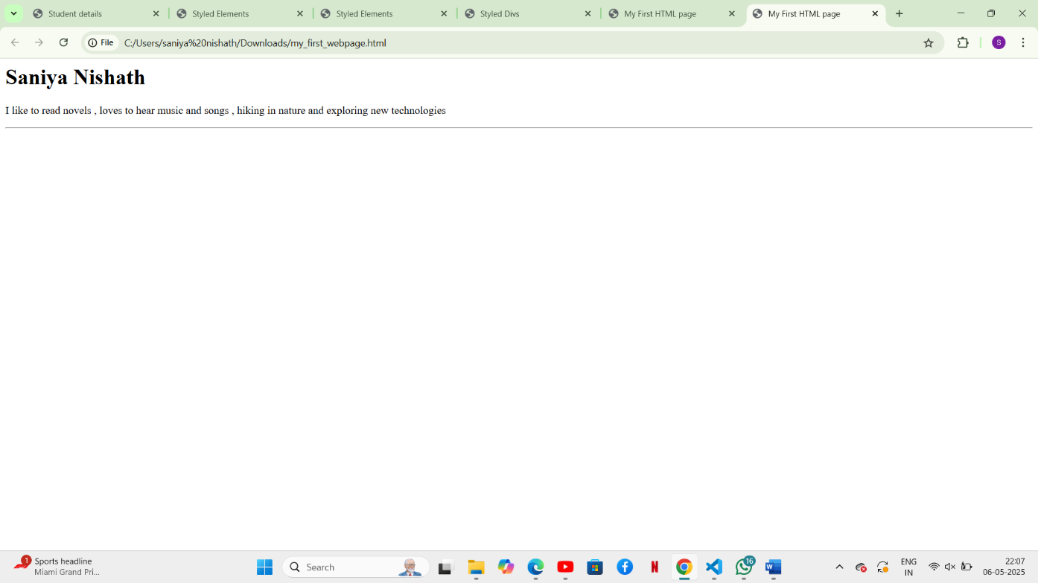

2. Use of Lists and Links

<html>

<head>

<title> My Favorite </title>

</head>

<body>

<h1> Favorite Fruits</h1>

<ul>

<li> Mango </li>

<li> Watermelon </li>

<li> Pineapple </li>

</ul>

<h1> Favorite Movies </h1>

<ol>

<li> Baby day out </li>

<li> Lapaata ladies </li>

<li> Bajrangi bhaijaan </li>

</ol>

<p>

visit my favorite website :

<a> href ="https://technologymagazine.com/articles/top-10-emerging-technologies"</a>

</p>

</body>

</html>

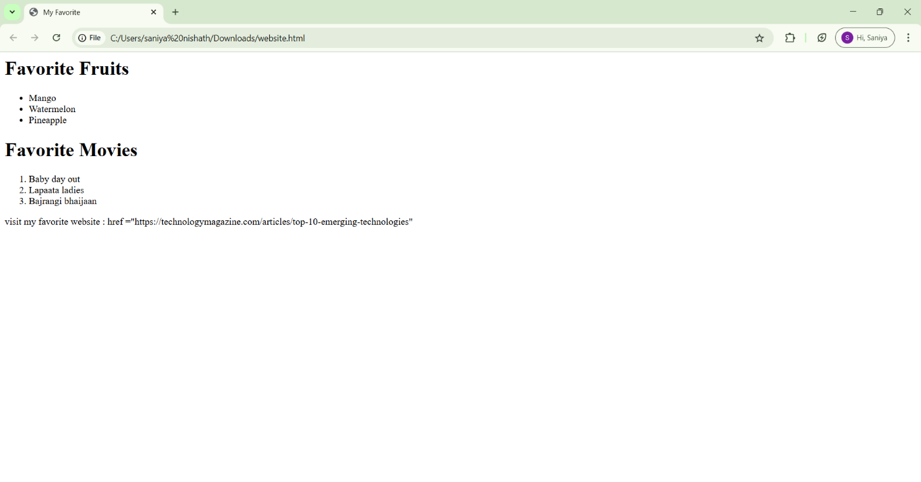

3. Adding Images and Tables

<html>

<head>

<title> Student details </title>

</head>

<body>

4

<img src ="https://i0.wp.com/picjumbo.com/wp-content/uploads/beautiful-nature-mountain-scenery-with-flowers-free-photo.jpg?w=2210&quality=70">

<h1> Student information </h1>

<table border ="1">

<tr>

<th> Student name </th>

<th> Age</th>

<th> Favorite subject </th>

</tr>

<tr>

<td> Saniya </td>

<td> 22 </td>

<td> Full stack </td>

</tr>

</table>

</body>

</html>

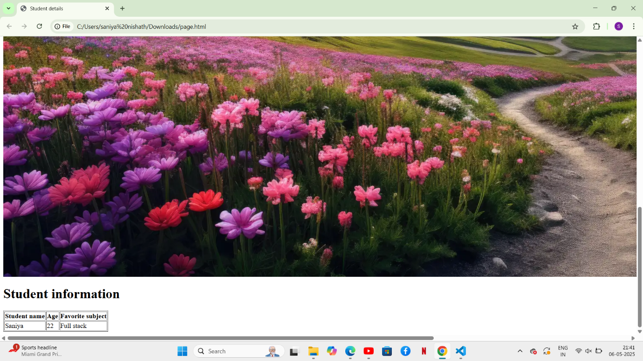

4. Introduction to CSS (Internal CSS)

<html>

<head>

<title> Styled Elements </title>

</head>

<body>

<h1 style = "background-color: lightpink; color : purple ; font-size : 30px;">

My Information

</h1>

<p style="font-family : Arial , sans-serif; text-align : justify;">

My name is Saniya nishath i am pursuing my Post graducation in MS Ramaiah institute of technology as M-tech in Computer science engineering .

</p>

</body>

</html>

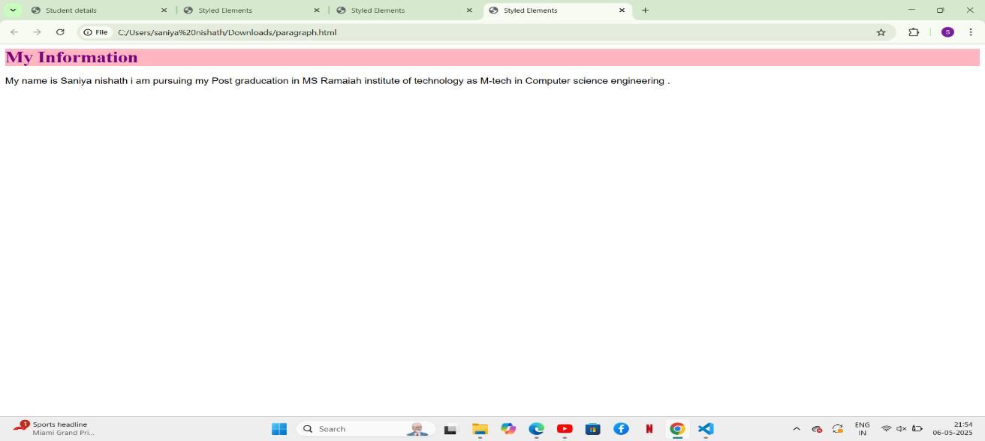

5. CSS Classes and IDs

<html>

<head>

<title> Styled Divs </title>

<style>

#intro {

border: 2px solid black;

padding: 15px;

}

.highlight {

background-color : skyblue;

}

</style>

</head>

<body>

<div id="intro">

<p> This is saniya .This page has borders and paddings around it.</p>

</div>

<div class ="highlight">

<p> This is highlighted section with background.</p>

</div>

</body>

</html>

